AGENDA - Little Hoole Parish Council  Members of the Council are summoned to the Parish Council Meeting to be held on  Mon 8th June 2026 at 7:00pm  The Lounge, Walmer Bridge Village Hall, Gill Lane, Walmer Bridge, PR4 5GN  Paul Cafferkey, Clerk & Responsible Financial Officer | 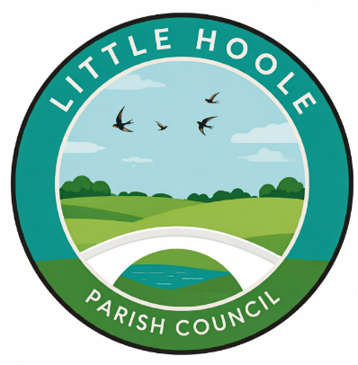
- Apologies for absence
- To agree the Minutes of the last Parish Council Meeting held on the 11th May 2026.
- To receive declarations of interest.
- Matters arising from the minutes of last meeting.
  - Public Time: to invite and listen to issues raised by members of the public.
  - To consider the following Planning Applications:
    - 07/2026/00343/HOH. 3 Farriers Fold Walmer Bridge PR4 5DR. Garden building.

  - To consider grant application for £2,500 from Little Hoole & Friends: Ground Force (in partnership with Little Hoole Primary School to deliver the development of outdoor learning and community-use spaces at Little Hoole Primary School.
  - To approve the following transactions in the bank for May 2026.
  - Payments approved by email or pre-approved and retrospectively noted:
    - Parish Council Insurance £470.19.
    - Information Commissioner’s Office £47.00
    - Purchase of two “anti dog fouling signs” at a cost of £62.66 (excl) for PRoW at end of Station Road.
  - Payments for approval: Clerk’s claim for May 2026
  - To note receipt of VAT Claim monies 2024-25.
  - To approve amendment to item 11a, minutes of 8 Dec 2025 re budget figures.
  - To note receipt of CIL monies.
  - To approve Finance Report as at 31 May 2026
  - To approve re-appointment of Internal Auditor (Helen Broughton) for 2026/27 at a cost of £220.00 (excl VAT).
  - To approve dates for the exercise of public rights for the inspection of accounts and supporting records relating to 2025/26.
  - To confirm email approval to appoint Community First Insurance as the Parish Council’s Insurers for 2026/27, as from 1st June 2026.
  - Proposal to set up a Parish Council Bio Diversity Grant.
  - Discussion re possible future project, PRoW information signs.
  - Update re Summer Activities Programme
  - Update re diversion of FP0707050 in relation to planning application 07/2024/0768/FUL
  - Update: re the replacement of the two bus shelters at the junction of Liverpool Old Road and Liverpool New Road (Star Garage).
  - Pond at Old Mill Court-re Lillies & Duck Sign
  - Fly Tipping
  - Update re Memory Bench.
  - Planned upgrade of Dob Lane Recreation Park
  - Update re Dog Fouling campaign.
  - Update re Summer Planting.
  - Update re removal of Post Box on Station Road.
  - Information and Updates.
  - Correspondence – None
  - To agree the date, time, and venue for the July 2026 meeting.
Members of the public are welcome to attend meetings to raise any relevant matters. Alternatively, if you cannot attend the meeting but wish to raise a matter or ask a question, this can be done on your behalf by contacting the Parish Clerk (Paul Cafferkey) via email clerk@littlehoole-pc.gov.uk or mobile phone 07966267186.
Visit the Little Hoole Parish Council Website https://www.littlehoole-pc.gov.uk or scan the following QR code.


Prepared and approved by Paul Cafferkey, Clerk – Little Hoole Parish Council,
3rd June 2026

